PhD End to End Assistance & Guidance

Institute for Engineering Research and Publication (IFERP) organized a webinar series on PhD End to End Assistance & Guidance, from August 14th, 2020 to August 20th, 2020 at 5:00PM (IST) on webinarjam. The objective of the webinar was to enlighten PhD Students, Research Scholars, Academicians and researchers on the recent trends and challenges faced during the journey of PhD.

The webinar was presented by eminent keynote speakers namely

SPEAKERS

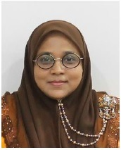

Dr. Zainab Ajab Mohideen,
Senior Information Technology OfficerCentre for Knowledge, Communication, and Technology (CKCT),
Universiti Sains Malaysia.
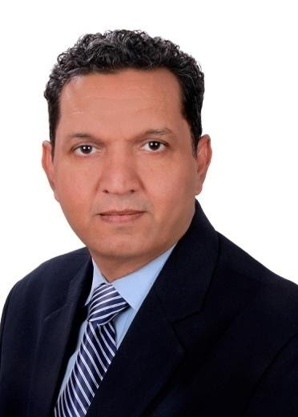

Dr. Pareshkumar Chandravadan Dave
Founder IP Moment,
Director IP of Dishmize & Tmize,
Cofounder Science Finder Association, Delhi, India
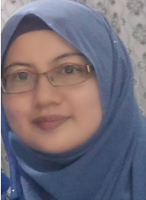

Dr Fatma Susilawati Mohamad
Associate Professor in Department of Information Technology
Faculty of Informatics and Computing,
Universiti Sultan Zainal Abidin, Terengganu, Malaysia.
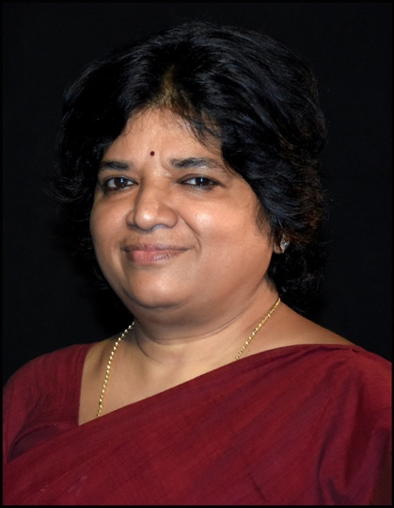

Prof. Supriya Pattanayak, Ph.D.
Vice Chancellor
Centurion University of Technology and Management, Odisha,
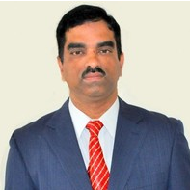

Dr. Ravichandran Krishnamoorthy
Professor at New York Institute of Technology
United Arab Emirates.
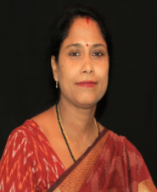

Dr.Anita Patra
Professor, School of Management
Registrar, Centurion University of Technology & Management
Parlakhemundi (Odisha)
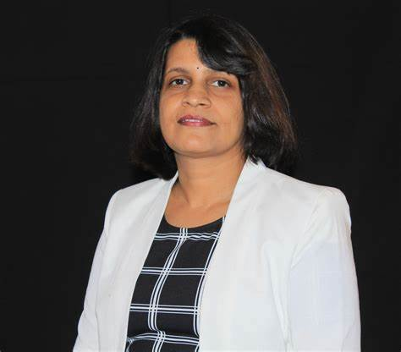

Dr. Prajna Pani
Professor of English, School of Management
Centurion University of Technology & Management, Odisha.
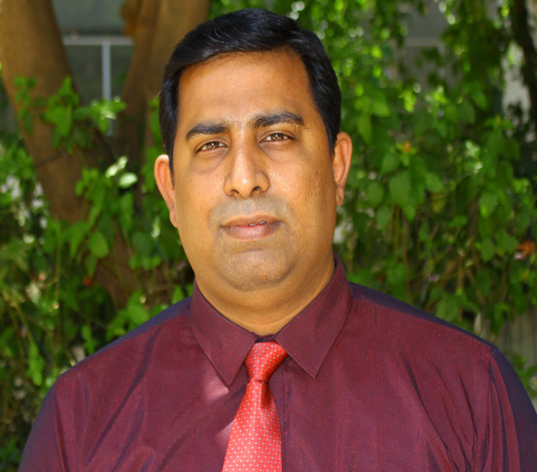

Dr. V.P.Sriram
Associate Professor of Acharya Bangalore B-School (ABBS),
Bengaluru, Karnataka, India.
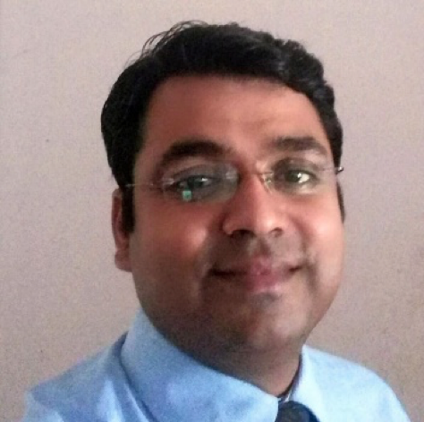

Dr. Subhendu K. Mishra
Associate Professor at School of Management,
Centurion University, Odisha.

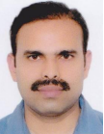

Dr. Jagadish Vengala, FIE, FACCE(I)
Head, EDC Innovation & Incubation Centre,
Associate Professor, Department of Civil Engineering,
PVP Siddhartha Institute of Technology, Vijayawada, AndhraPradesh

The Keynote Speakers broadly discussed on the following topics,

- Translation of your technical proposal and idea
- Title Finalization
- Research Proposal
- RDC Preparation
- Synopsis
- Literature Survey
- Problem formulation & Identification
- Technical Implementation
- Thesis Writing
- Thesis Editing
- Defend your research methods & methodologies
- Innovative Research Opportunities

Highlights of the Webinar:
- E-certificate was provided to all attendees.
- Free IFERP membership was provided to all attendees with membership certificate.
- Telecasted Live on YouTube.

YouTube Channel Link: https://bit.ly/2YkMbRA

The webinar was attended by more than 200 attendees and viewed live by more than 1k subscribers on YouTube

