IP Challenges in Engineering, Science and Technology - Advanced Concepts

Institute for Engineering Research and Publication (IFERP) organized a webinar series on IP Challenges in Engineering, Science and Technology - Advanced Concepts, from August 7th, 2020 to August 11th, 2020 at 5:00PM (IST) on webinarjam. This webinar series was for any new innovators such as professionals, individuals, universities, industries, Law firm, start-up companies, MNC’s, authors, inventors, business man who has innovative ideas in the field of Intellectual property.

SPEAKERS

Ms. Namrata Pahwa
Advocate, Intellectual Property Litigation,
Advisory and Civil Dispute Resolution
New Delhi, India

Enrico Bonadio
Reader in Intellectual Property Law
City University of London, London
United Kingdom
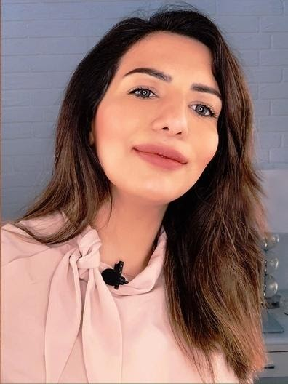

May M. Hassan
Intellectual Property Attorney
WIPO Certified IP Trainer
IP Field Researcher Egypt

Leticia Khater Covesi
CEO at I9PI & Collaborating Professor at UNICAMP
Campinas, Sao Paulo, Brazil
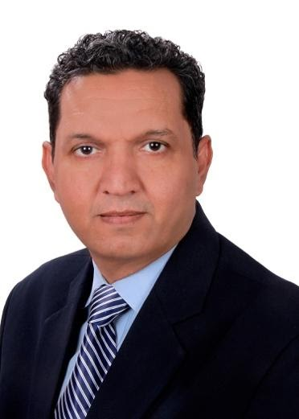

Dr. Pareshkumar Chandravadan Dave
Founder IP Moment
Director IP of Dishmize & Tmize
Cofounder Science Finder Association, Delhi, India
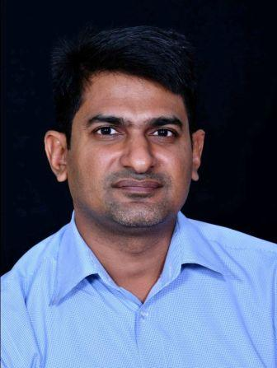

Mr. Pankaj Kumar
IP Attorney,
IPR Trainer & Facilitator (Patent, Industrial design, Trademark, Copyright and GI),
Asst. Professor at IIS deemed to be University, Jaipur, India.
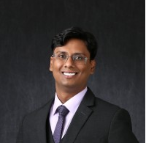

Mr. Govind Kedia
Chief Operating Officer & MD ,
Arctic Innovation Consulting Sol. Pvt. Ltd
India.
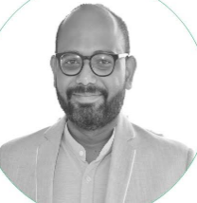

Prosenjit Mondal
Senior IP Attorney,
Arctic Invent,
India.

The Keynote Speakers broadly discussed on the following topics,

- Introduction to IPR
- Types of IPR
- Patent Search
- Patent Drafting
- Patent Drawing
- Patent Filing
- Copy Right
- Trade Marks
- Intellectual Property Rights & Management
- Handling & Managing IPR

Highlights of the Webinar:
- E-certificate was provided to all attendees.
- Free IFERP membership was provided to all attendees with membership certificate.
- Telecasted Live on YouTube.

YouTube Channel Link: https://bit.ly/2YkMbRA

The webinar was attended by more than 100 attendees and viewed live by more than 500 subscribers on YouTube

